Switching Languages
Laura Daniela Brinez Camacho
Student at Loras College

Abstract
This study was conducted to identify how many international students at Loras College, switched languages from English to their native language, whichever it was. For the experiment the researcher recorded people having casual conversations and in a certain time, she recorded how many times people switched languages. All this study was made with the purpose of making aware the students that they are actually doing it, because sometimes they do it unconsciously and are unaware of it. The results showed that mainly conversations along males and females are the ones that present the most changes of language. However, questions like why do they decide to switch languages to begin with? Still need to be solved in future studies.

Switching Languages
9% of the students at loras College are international. This not only involves people who talk Spanish, but also, French, Chinese, Indian and Japanese. This being said I must include myself in that percentage of international students and that’s why I thought doing this research study was going to be interesting. What I was looking with this research was to look up how many times did international students switched their languages when they were having a casual conversation. I wanted to look at this because, people sometime do it without being aware of it, and it is interesting to see with actual numbers how many people do it too and with what frequency. For this study, the variables measured were simply the gender of the people talking just to have and overall idea of whom tended to switch more of language and the number of times they actually did it. Consequently, the hypothesis I got to was that International Students at Loras College, specially females, tend to switch languages on an average of 3 times per a 2 minute interval.
Method
Participants
For this experiment, I am going to be observing International Students at Loras
College, who frequently attend the Intercultural Programs Office, mostly known as the IPO. In total there were 33 individuals evaluated, and they were picked at random depending on if they started a conversation or not.
Materials
Laptop to record data
Procedure
For the study, I decided to record people for a period of time of 4 hours, 1 hour and a half per day. I went to the Intercultural program Office and sat in a random spot of the place pretending I was doing homework, while I was actually listening to peoples conversations to record how many times they switched languages. Every time a person changed from one language to another, that counted as a change and when it went back to the one they were speaking before, counted as another change. For my group of study I decided to look for groups of either two or three persons from different genders and record how many times they made a change during a time period of 2 minutes. If I saw the conversation was over among the individuals before the 2 minutes ended, I waited for 15 seconds and after that, I would switch to another group. The data was recorded in a table like the one shown below:
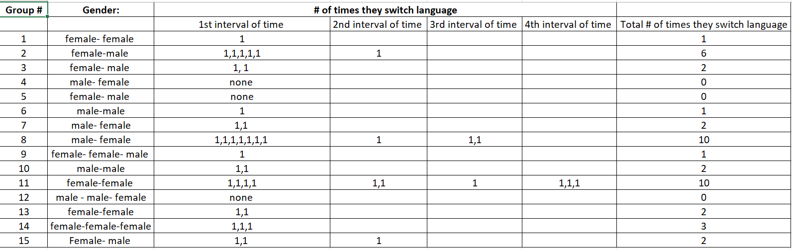
Results
The results show that overall, a female-male and female-female conversations is the one that tends to have more switches in language with averages of 22 for female-male conversations and 13 for female-female conversations. On the other hand male-male conversations, and groups with 3 members were the ones who score the least amount of switches. Male-male got a total of 3 and for example a group made up by male-male-female scored 0 switches. The group composed of 3 females also scored 3, being one of the lowest ones.

Discussion
My initial hypothesis was that International Students at Loras College, especially females, tend to switch languages on an average of 3 times per a 2 minute interval. As I conducted my research I could tell I was partially right on my hypothesis but I wasn’t completely accurate on some others aspects. For example when I conducted the research there was a pair of females who switched language 10 times in a 4 period time interval. However, after concluding my research I also noticed that pairs made up by a male and a female tend to switch a lot their language too, for example in one, they switched 6 times in a 2 period interval and in another they also switched 10 times in a 3 minute interval. The variation in the time intervals might have been mainly because people had a conversation for a minute or two, but after that they stopped speaking, or maybe even not completing a 2 minute conversation, they finished talking, so I had to stop recording after giving them a 15 second space.
You may refer back to the literature review if you would like. On the other hand, even though female-male conversations where the most recorded, 2 of them had no switch of language during the 4 period interval. Likewise, the groups that were formed by more than 2 people tend to stay more on 1 language and it was harder for me to identify whom change when, since they could be multiple conversations at the time. On the same line, talking about some of the challenges, it was also hard to record people during a 2 minute interval when they stopped talking and another group started talking and I wanted to record that other group without losing the first one. Also, when people were speaking to low and you try to pay attention, they could misunderstand you and think you were snitching into their conversation while the only thing you were actually trying to do was record the amount of changes. It is challenging when you are located in a place where multiple conversations are occurring at the same time and you want to focus on just a certain part of them. For future investigations, researchers should try to find out the actual reason people do this (switching languages). Is it because they feel more comfortable doping it? Is it because they gain more confidence when they are talking on that other language? To maybe look cool? Those are possible research questions that researchers can try to solve with this study as a base.
Table
These tables show the relationship of gender groups and the number of times they switched languages in a conversation.
1st table: shows the data when conducting the research
Second Table: shows the data organized and summarized in a way is easy for the observer to look and understand.
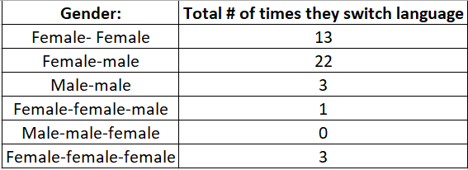

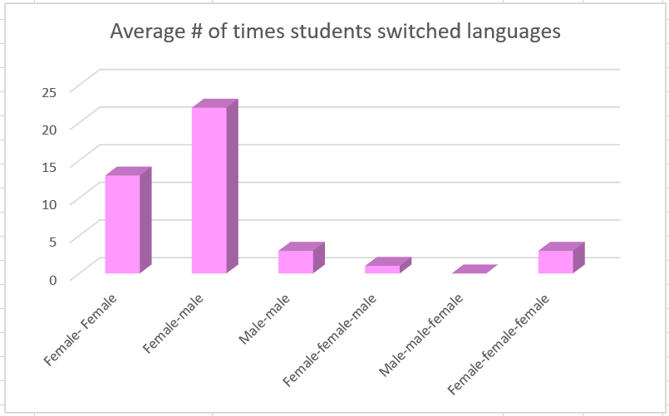
Figure 1. Average number of students switched languages.

